Purpose | People engaged with the services we provide, staff and people spending time at our organisations facilities are provided with a suitable and accessible physical environment. All facilities are fit for their purpose.
Scope | All buildings, services are provided in or from.
References
Legislation | Electricity (Safety) Regulations 2010 – sect 26  NZS 8134:2008 Health and Disability Services Standards  The Building Act 2004
Guidelines | Auckland City Council Consents  Bathroom and Toilet Hygiene in the Home  Building Warrant of Fitness  Code of Compliance  Consultation Report: Access to Buildings for People with Disabilities  Energy safety  Guide to hot water cylinder temperatures  Homes without Barriers
Organisation’s  policies/  procedures | Asset Management  Emergency and Security Systems  Health and Safety Manual  Infection Prevention and Control Manual  Smoke free Environment

Buildings and Property
Our organisation will comply with the relevant building codes and requirements.
It will maintain a Building Warrant of Fitness (BOF) or Code of Compliance Certificate (CCC) or provide evidence that a BOF or CCC is not required.

Safety

Manager/CEO & staff

Building requirements
Equipment

- All equipment will be purchased from reliable sources.
- Only registered trade’s people will install/repair equipment.
- People will have orientation to equipment they will be using.
- Staff will be oriented to all equipment during their induction process.
- Equipment will be calibrated in line with the maintenance log.
- Required adjustments will be made for people
engaged with our service that have disabilities.
- Rental or property purchases consider
amenities for people with physical disabilities.
- Consideration is given to ensure that our buildings comply with infection prevention and control requirements when purchasing/renting a new building or when renovating.

Enough showers are available to the people engaging with our services.
Shower rooms:
- Can be locked.
- Can be accessed by staff in case of an emergency.
- Have a non-slip floor.
- One shower is accessible to service users requiring mobility aids.

There is a separate staff shower.

Our organisation ensures that there are enough toilets for the people engaged with our services. All toilets:
- Can be locked.
- Can be accessed by staff in case of an emergency.
- Have a hand wash basin.
- There is a toilet that is accessible to service users requiring mobility aids.

There are separate staff and visitor toilets.

Access to Toilet, Shower and Bathing Facilities
Showers
- The outside will be maintained to manage fire and injury risks.
- People engaged with our services will have the opportunity to establish and/or maintain a vegetable garden.
- Decks and entrance steps are safe and of a non-slippery surface.
External Areas
- Furniture will be made from safe materials and of an acceptable quality.
- Soft furnishings that are easy to clean.
- Windows that can be secured.

Interior
Are made from material that can be cleaned in line with infection prevention and control practices.
Example materials:
- Tiles, plastic, metal, formica, acrylic, ceramic, lino.
Bathroom, Toilets &
Laundry and Kitchen
Toilets
People have the right to use the toilet and shower of the gender they identify with.

Future rentals or building purchases will include enough toilets and showers so one can be designated specifically for infection isolation purposes.

Our staff is mindful of the possibility that toilets and showers can trigger past trauma experiences for the people engaging with our services.

Cleaning and Laundry
Wash Basins

Cleaning schedules and laundry processes are included in the Infection Prevention and Control manual/plan.
- Some service will store cleaners and laundry chemicals in a locked cupboard.
- Internal audits are implemented (refer to quality plan) to assess the effectiveness of the cleaning and laundry processes.
Wash basins are available in:
- each toilet
- shower/bath rooms
- kitchen
- laundry
- staff toilet/shower
- room where medication is administered

Water Temperatures

Water temperatures:
- Will be 45°-55° at the tap/shower head.
- Will be monitored monthly – a record will be maintained.

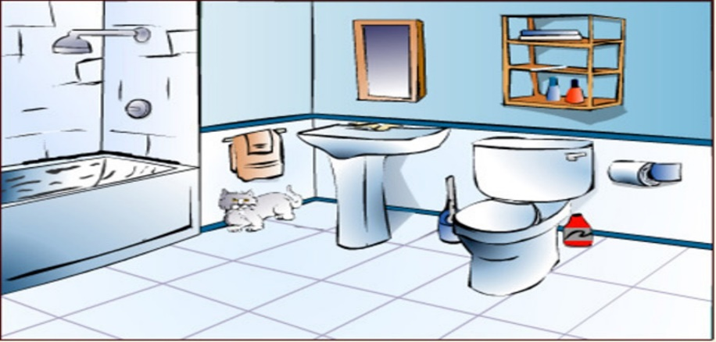

Personal Space/Privacy

Privacy
Bedrooms

- All bedrooms are single – unless a clinical justification indicates otherwise and the person agrees to the arrangement.
- Windows have curtains.
- Staff will knock on the door prior to entering.
- Visitors cannot enter a person’s bedroom without their permission.
- The person has access to the bedroom at all times.
- The person has the opportunity to store their possessions safely (examples: lock their bedroom door, have a lockable cabinet).
- People using mobility aids are able to move safely around their personal space/bed area.
- All bedrooms have windows that provide natural light.
- The windows will have curtains.
- People engaged with our services:
  - Have a phone available in an area where calls can be made in privacy.
  - Have access to meet visitors in an area where privacy is ensured.
  - Have a one-to one or meetings with service providers in privacy.
- Photographs/videos cannot be taken without the person’s written permission.
- Photographs/videos cannot be published without the person’s written permission.
- Visitors are informed to respecting people’s privacy (refer to visitor policy/procedure).

Personal Items
Communal Areas

- Staff will not use any of the person’s possessions such as mobile phones, cameras, radios etc. (refer to professional boundaries).
- Staff will not remove a person’s possessions without discussing this with the person.
- Service users are responsible to keep their possessions safe.

Are available for:
- dining
- recreation
- meditation/contemplation/prayer
- work
- sports/exercises
- sensory modulation

Ventilation and Heating

Heating
Ventilation

Ventilation guide
Tackling dampness
Cooling the building
Room temperatures
Types of heather

Building and Property Maintenance

All staff will be familiar with the location of the fuse box, water main and hot water cupboards.
People engaged with our service are provided with information how to access maintenance support.
Repairs

Urgent Repairs
Routine Maintenance

Staff on duty/people living at the premises
Click here to enter text.
Click here to enter text.

- Is carried out according to the maintenance log.
- Staff will contact the Click here to enter text. once the need for repairs is identified.
- The approved suppliers will be contacted to arrange the repairs being done.
- The approved suppliers list is available on Click here to enter text.

- Inform the staff on duty.
- Staff on duty will contact the approved suppliers to arrange repair.

Follow the Health and Safety processes if it is a health and safety issue

Consultation
Group/Role | Date

