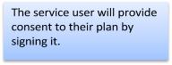
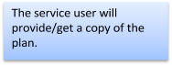
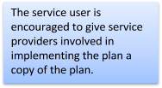
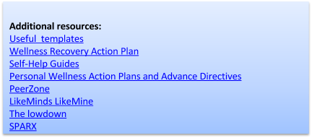
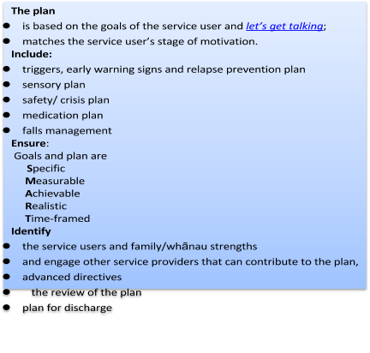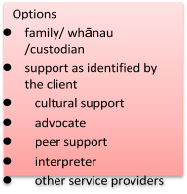

Purpose | The service provision plans and interventions are based on the service users and their family/whānau assessed needs.
Scope | Service providers, service users and their identified supports that are involved in service delivery. Service delivery plans will need to include aspects of contractual requirements.
Policy | The service user plan is determined by the service user.

Version  : | V 2 | Issued | August 2017 | Created by: | GSHarnisch | Revie w | August 2020 | Authorised by:

Consultation

Group/Role | Date

Version  : | V 2 | Issued | August 2017 | Created by: | GSHarnisch | Revie w | August 2020 | Authorised by:

