Purpose | The service will ensure that they provide a smokefree environment and that smokefree lifestyles amongst staff, service users and their family/whānau are supported.  To comply with legislation and contractual requirements.
Scope | Any person on the services premises or in cars.  Any types of smoking including the use of E-cigarettes.
Performance Indicators | - Smokefree contract clauses are met.  - Legislative requirements are adhered to.
References

Legislation | Health and Safety at Work Act 2015  New Zealand Public Health and Disability Act 2000  Smoke free Environments Act 1990 and amendments 2003  Smoke-free Environments Regulations 2007
Information | Ministry of Health E-cigarettes information  Ministry of Health Health Strategy 2016  Ministry of Health Smokefree Information  Smokefree Wellplace NZ
Standards  Guidelines | New Zealand Guidelines for Helping People Stop Smoking
Organisational Documents | Health and Safety Manual  Using Company Vehicles
Smoke free environments include:

Property leased
Property owed

Anywhere inside the building.

Within the boundaries of the outside property.

Company cars.
Any building or property where services are delivered.

Smoking includes:

Cigarettes

Any form of tobacco.
Any natural or synthetic substance.

E/vapor cigarettes.

Smoking in public

Personnel are not to smoke while exposing organisational identification such as:
- clothing
- lanyards
- name badges
- in cars that display the organisations name

Smoking in service users home or community setting

- Personnel are not allowed to smoke at service users home.
- Personnel must endeavour to minimise their own risk to second-hand smoke in those settings.
- Personnel must not smoke in private cars with service users being a passenger.

Smoking at work
- Personnel are not allowed to smoke at service users home.
- Personnel must endeavour to minimise their own risk to second-hand smoke in those settings.
- Personnel cannot smoke during work time. If they wish to smoke it will only be during scheduled breaks.

Promoting a smoke-free environment:
- Visitors, volunteers and contractors are informed of the smokefree status.
- Smokefree posters are displayed at the service:
  - staff room
  - reception
  - entrance to the building
- This policy/procedure will be displayed with the visitors’ book.
- If smoking occurs in the smoke free area it will be noted on the hazard identification and investigated.

- All service users will have a smoking assessment.
- Ensure smoking information is reported to the funding agency as per agreement.
- All service users who are smokers are provided with smoke cessation information and/ or treatment (6-monthly).
- Service users are referred to smoking cessation support as required.
- Service users ongoing breach of the smokefree policy will result in a review of the support offered and will be noted through the adverse event system.
- Include smoke status in the recruitment questionnaire.
- Staff are offered smoking cessation support.
- Using smokes as a behavioural tool or de-escalation mechanism is prohibited.
- It is prohibited to smoke with clients to build rapport.
- Three breaches of the smokefree policy is misconduct and will result in disciplinary procedures.
Employees/Personnel
Smoking cessation and support information will be made available to every smoker entering the building by having it on display.
Service users
Building
Workforce development and training

- All staff will be made aware of the services Smokefree Environment policy/procedures during their induction process.
- Staff will complete the Ministry of Health smokefree e-learning module at least every two years.
- Staff will also be encouraged to become Quitcard providers by completion of Smoking Cessation Practitioner training or via completion of the e-learning module (registered health professionals).

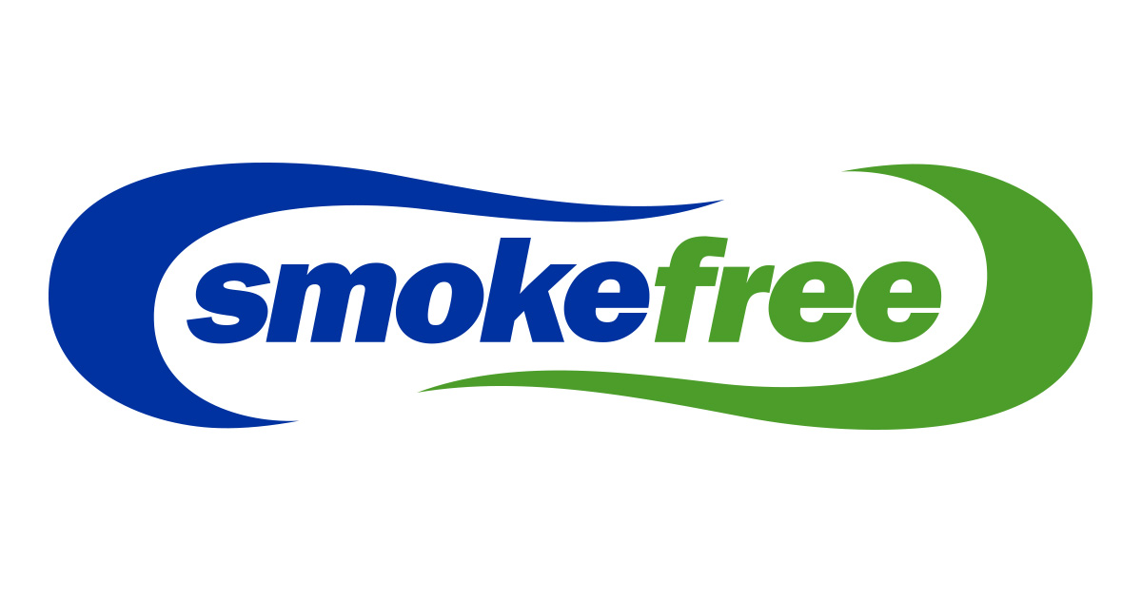

Consultation

Group/Role | Date

