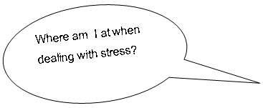

What do I need?

What are we going to do?

When will we do this?

Who is involved?

What happened?

Am I losing the plot when I am stressed? How?
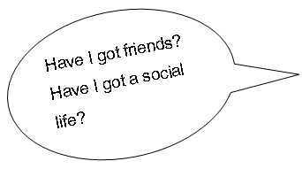

What do I need?

What are we going to do?

When will we do this?

Who is involved?

What happened?

Am I isolated?
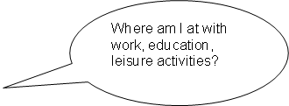

What do I need?

What are we going to do?

When will we do this?

Who is involved?

What happened?

Any danger that I lose interest?
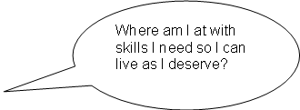

What do I need?

What are we going to do?

When will we do this?

Who is involved?

What happened?

Any danger that I am not looking after myself or others?

